Hostel Booking Management System

By

muhammad mehran amjad

BS computer science

The Department of Computer Science & Information Technology,
The Superior University, Lahore



SUPERIOR UNIVERSITY
Gold campus, 6km, Raiwind Road, Lahore

2023-2027

Project Advisor:

Miss Saba Ramazan

PROJECT CONTENT:
- TABLES
- ERDS
- QUERIES
- VIEWS
- VALUES INSERTION/DELETION
- PARAGRAPH

- PARAGRAPH:
Summary
The objective of this MS SQL project is to design and implement a database system that effectively manages hostel bookings. This database will be tailored to support a hostel booking system with structured data organization, streamlined CRUD (Create, Read, Update, Delete) operations, and views that facilitate comprehensive data analysis and management. The proposed project will demonstrate the database with primary keys, foreign keys, and relational database concepts.

Project Scope
The project scope includes the following components:
- Database Design: Development of a relational database with tables capturing critical data points in hostel bookings.
- Table Structures: Creation of tables with primary and foreign keys to ensure data integrity and efficient querying.
- CRUD Operations: Implementation of CRUD queries to manage records effectively.
- Views: Definition of views for easy data retrieval and generation of reports.

Key Functional Requirements
- Hostel Management: Store details for each hostel, including name, location, and owner details.
- User Management: Track user types (e.g., hostel admin, students) and details for all users, with associated booking and ownership histories.
- Room and Facility Management: Define room categories, facilities, and room details.
- Booking Tracking: Enable tracking of room bookings done by students.
- User Feedback: Collect and store feedback from users.

- TABLES USED:
We use sql server Management Studio for creating a db And tables
We are working in a project of Hostel Management System that consist of least of 10 Tables:

We have 10 entites and have their attributes.
- User type_tbl:
User type-id(pk)
Type [owner/candidate]

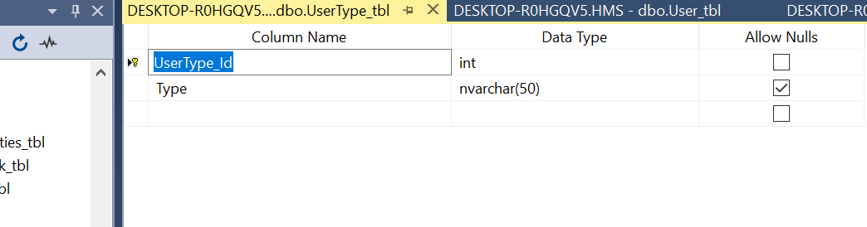
- User-ID(pk)
Name
Contact(Number)
Cnic
Addrees
User type-id(fk)
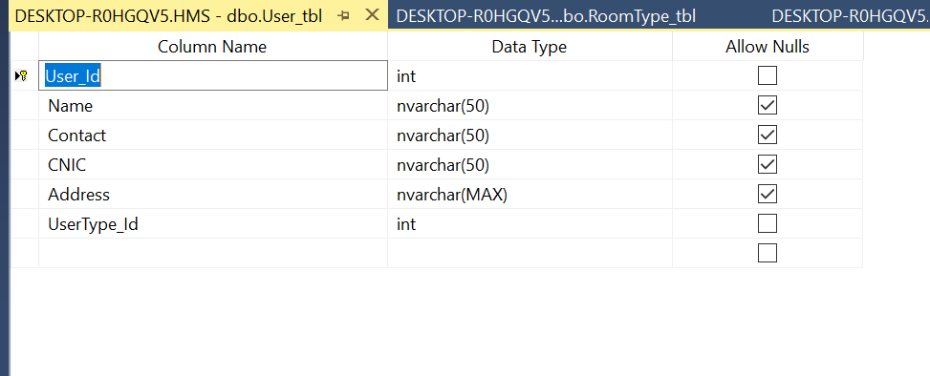
- Hostel_tbl
Int hostel_id(pk)
Hostel_name
Address
City
Phone
User id(fk)

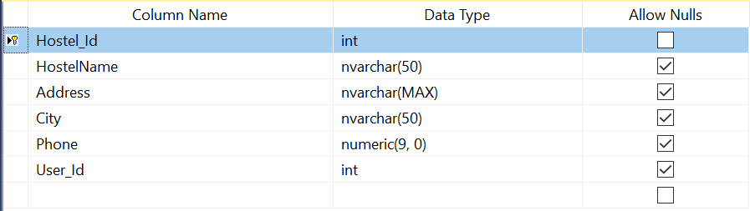
- Room_type_tbl
R-type -id(pk)
Type(single/shared)

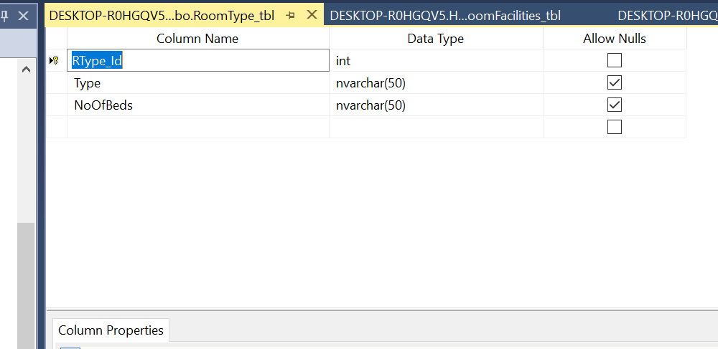

- Room_tbl
Room_id(pk)
Room no
R-type_id
Floor
Hostel_id

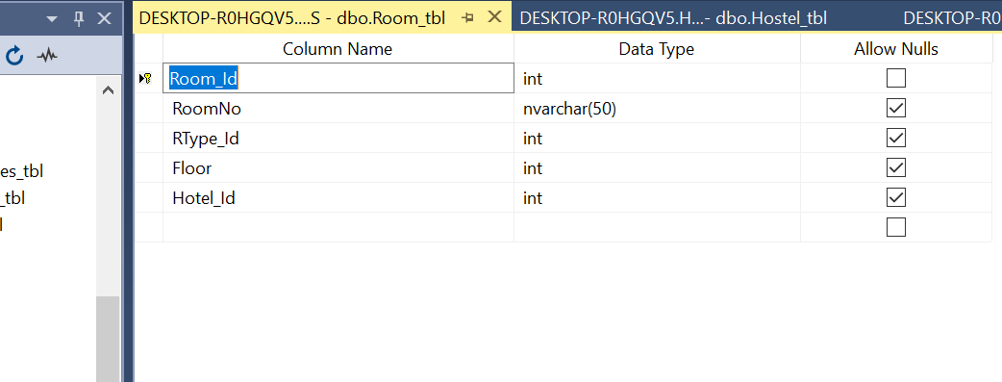
- Facility tbl
F-id(pk)
F_name

- Room_facility_tbl
RF_ID (pk)
Room-id(fk)
F_id(f.k)
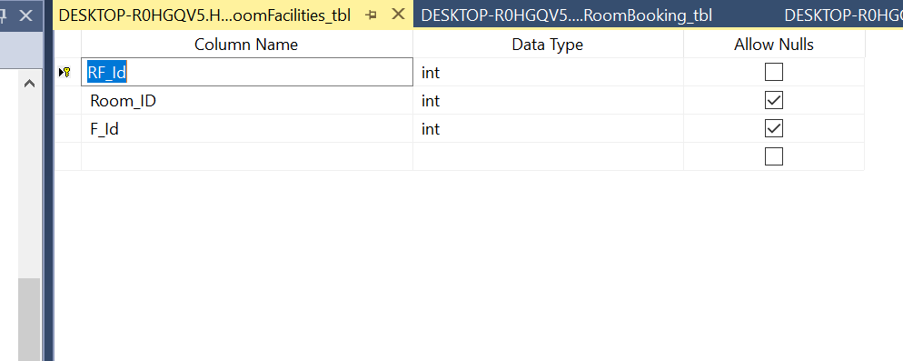
- Room_booking Table
Room_booking_table(pk)
Room_id(f.k)
User id

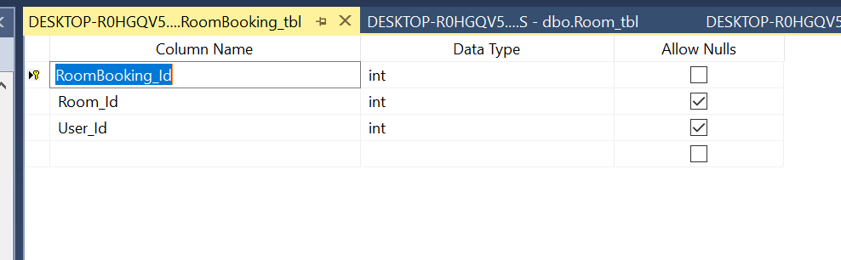
- Amenites
Am-id(pk)
Hostel_id
Amenity{wifi/parking}

- Feedback_tbl
Feedback_id(pk)
Hostel_id (fk)
Status
Comments
User_id(fK)
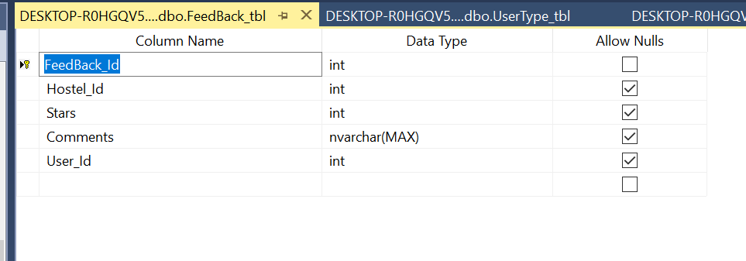

- ERDS DIAGRAM

DESIGING A HMS

PROOFS OF DESIGINING TABLES AND ERD
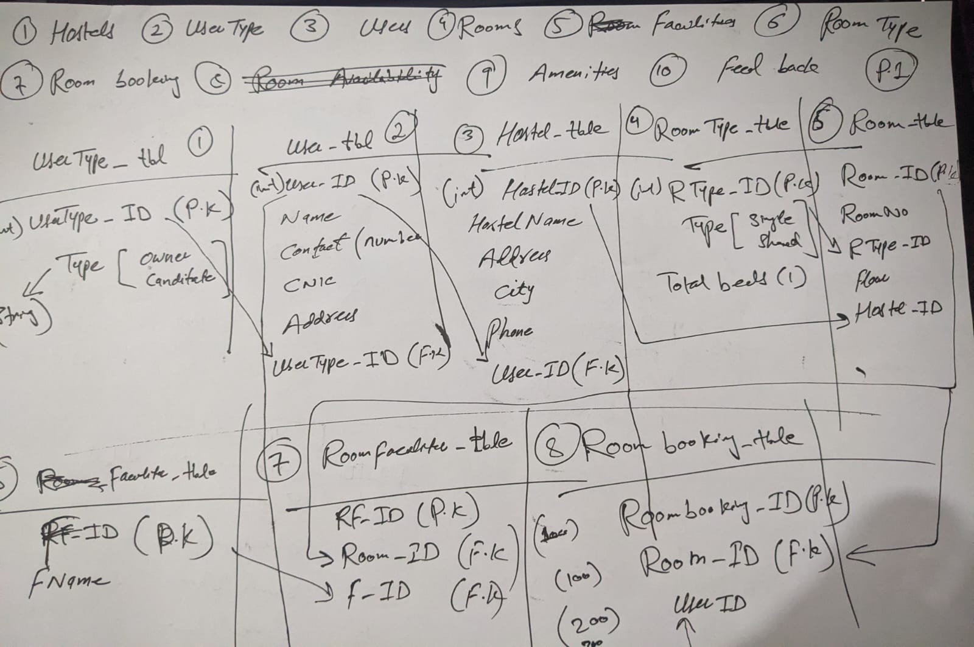

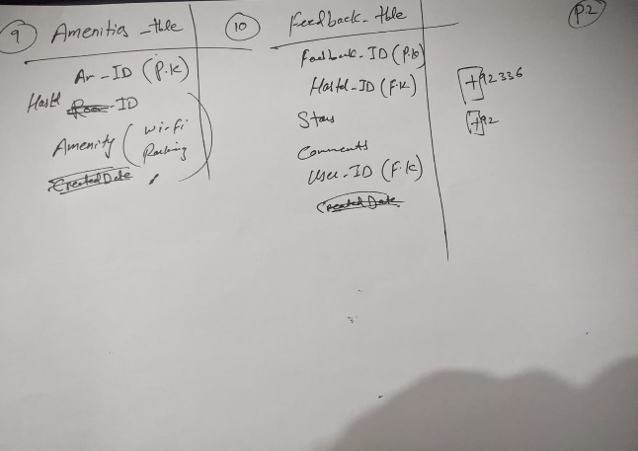

MAIN DIAGRAM
We use Draw.io to draw manually Erd just put and Draw manually erds and relate relations with each other by Put Pk and fk for table linking and relations to proper write a queries and code on sql

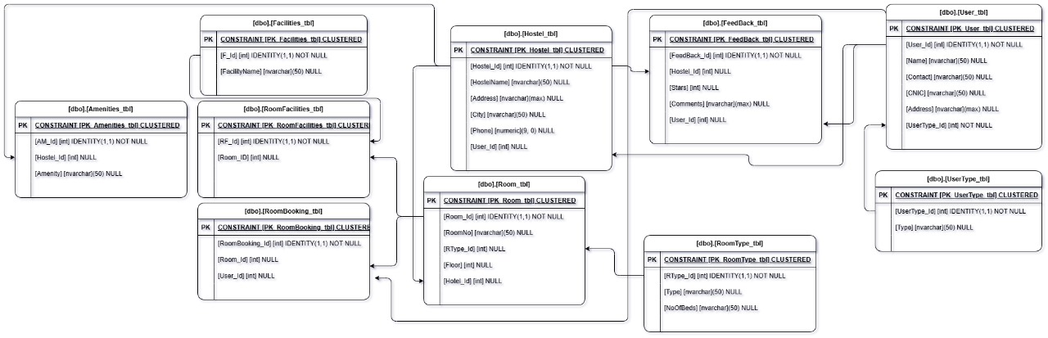

PROOF:
